**Use Case Diagram**

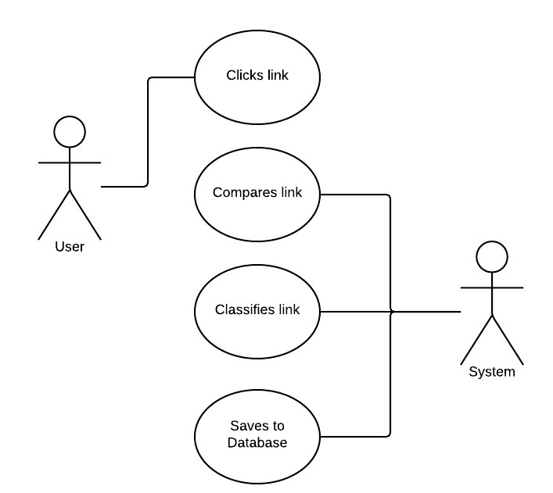

**Use Case Full Description**

|  |  |
| --- | --- |
| Use Case | Clicks the link |
| Actor: | User |
| Description | The user clicks the link |
| Flow of Events | 1. User clicks the link. 2. The system runs. 3. Use case ends. |
| Pre-condition | The user should click the link. |
| Post-condition | The system will run |

|  |  |
| --- | --- |
| Use Case: | Comparing detected link |
| Actor: | System |
| Description: | The system will compare the detected links. |
| Flow of Events: | 1. The system request data from database 2. The system compares the detected link to the list of fake/authentic news in database. 3. Use case ends. |
| Pre-Condition: | The user should click the link. |
| Post-Condition: | The system compared the detected link. |

|  |  |
| --- | --- |
| Use Case: | Classifying detected link |
| Actor: | System |
| Description: | The system will classify the detected links. |
| Flow of Events: | User clicks the link   1. The system will classify whether the compared link is fake or not. 2. Use case ends. |
| Pre-Condition: | The system should compare the link. |
| Post-Condition: | The system classified the detected link. |

|  |  |
| --- | --- |
| Use Case: | Save to database |
| Actor: | System |
| Description: | The system will save the classified link to the database. |
| Flow of Events: | 1. The system will save the classified link in database 2. Use case ends. |
| Pre-Condition: | The system must classify the link |
| Post-Condition: | The system saves the classified link to the database. |

**Use Case Full Description**

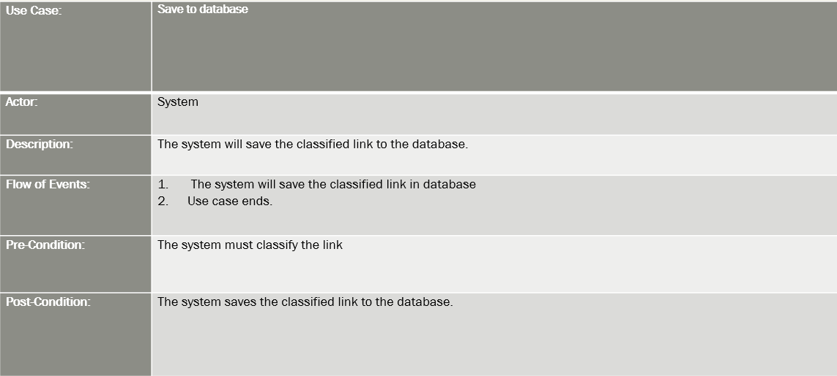

**Event Table**

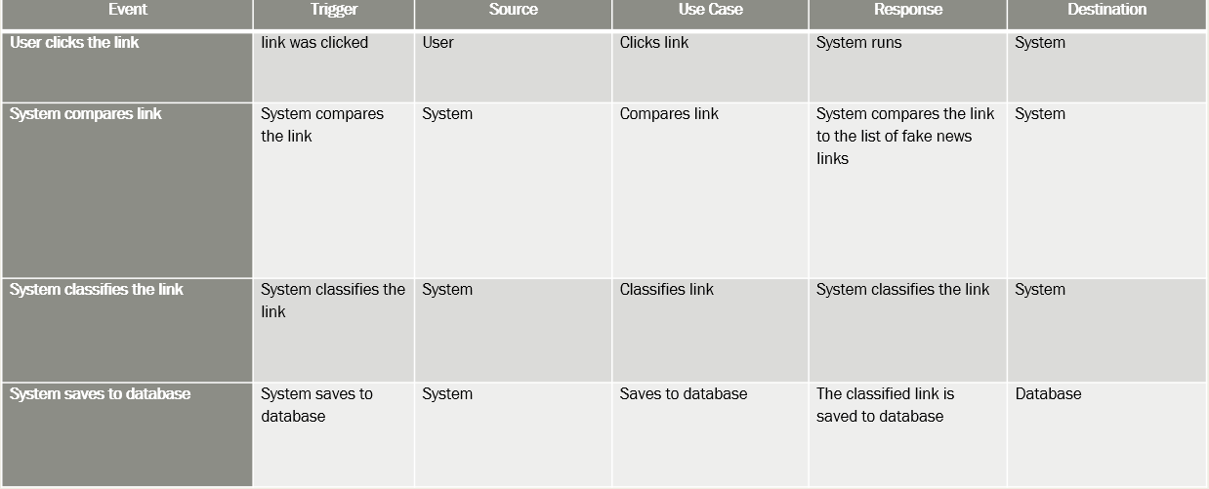

**Activity Diagram**

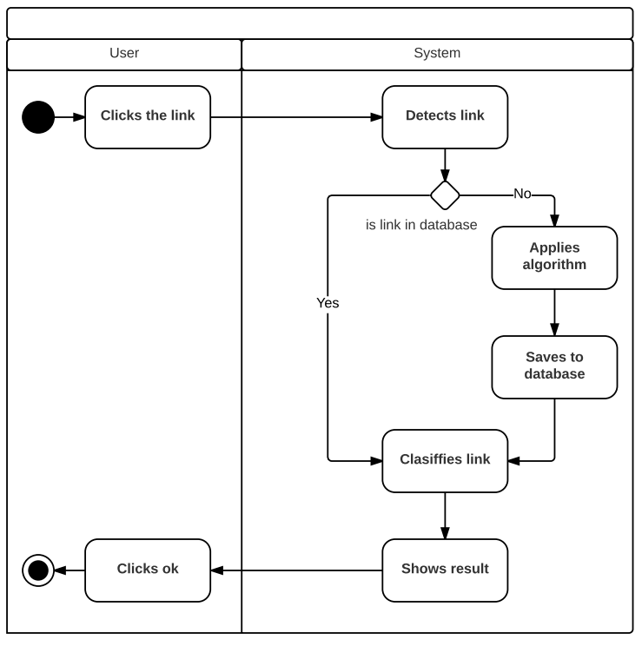

**Sequence Diagram**

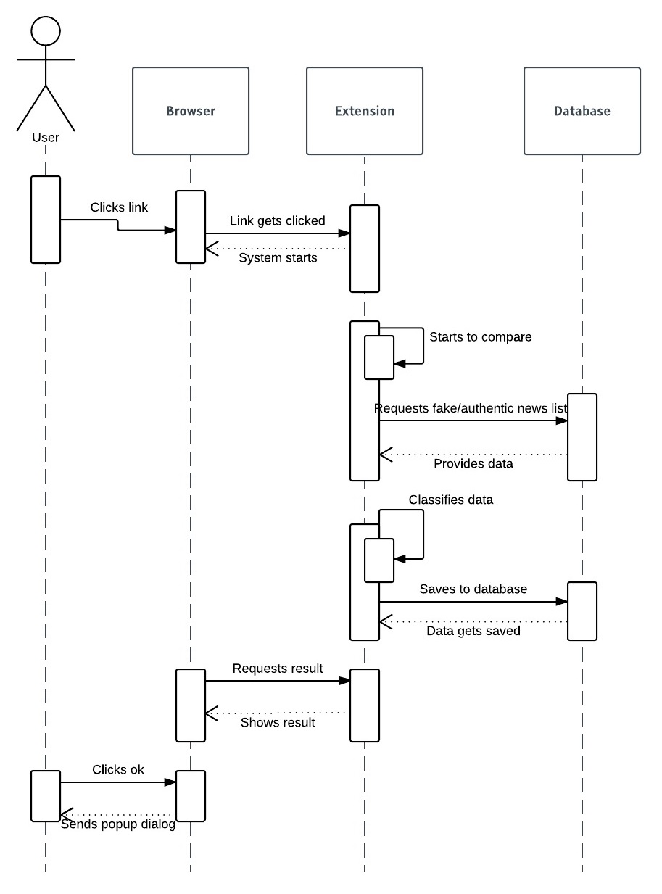

**State Diagram**

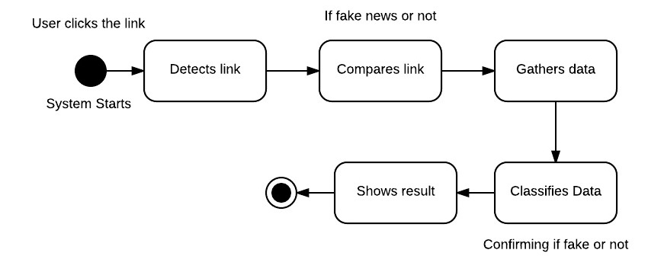

**Timing Diagram**

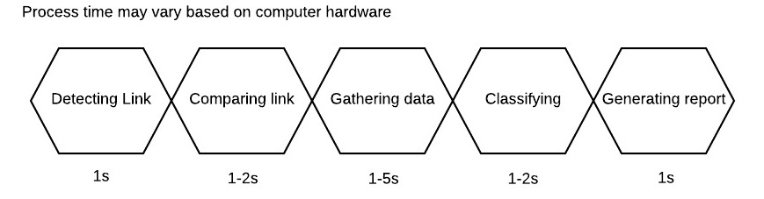

**Class Diagram**

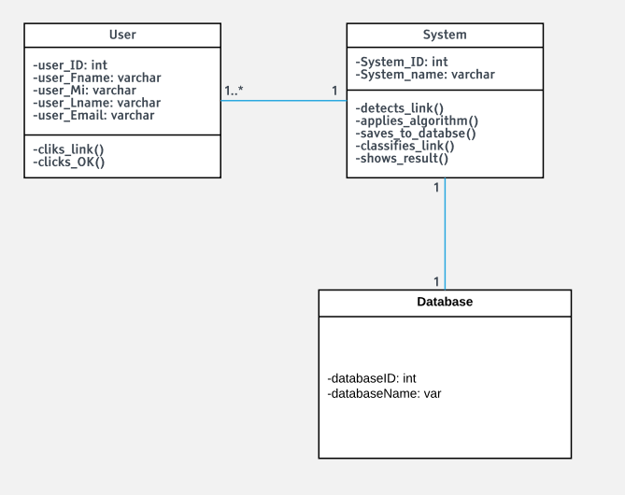

**Communication Diagram**

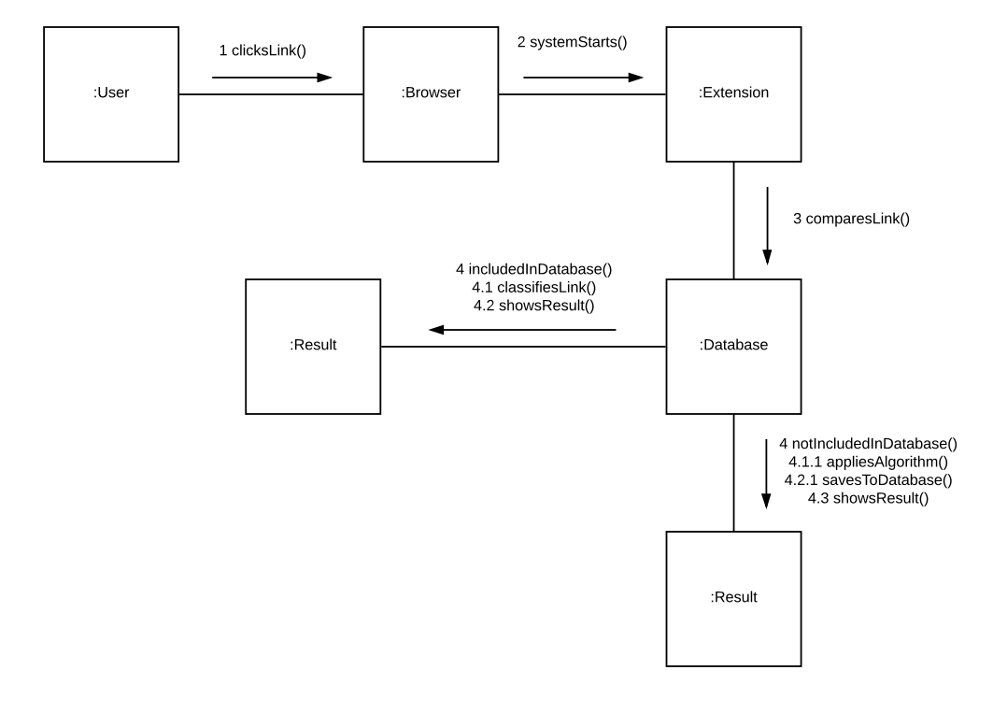

**Component Diagram**

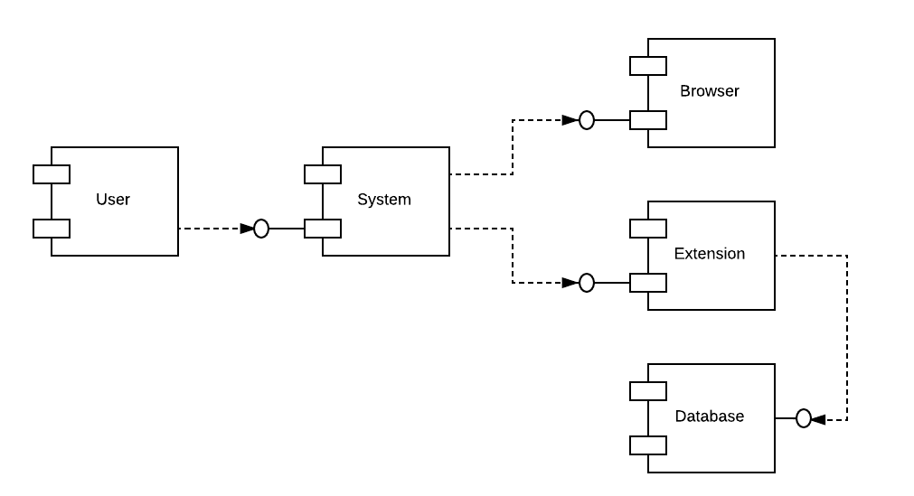

**Composite Diagram**

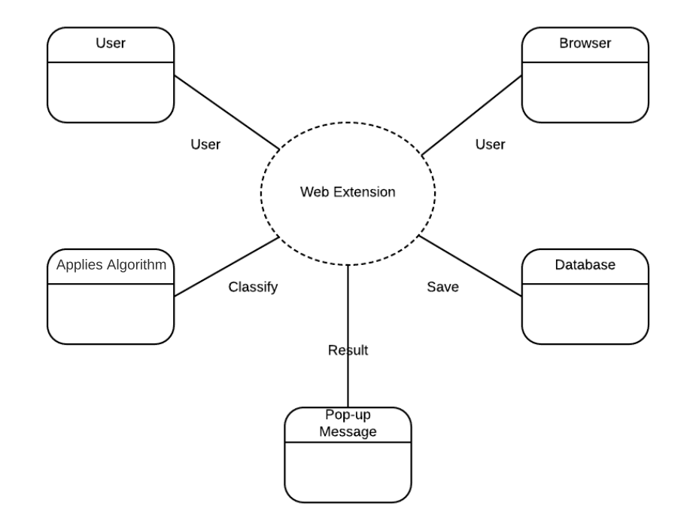

**Interaction Overview Diagram**

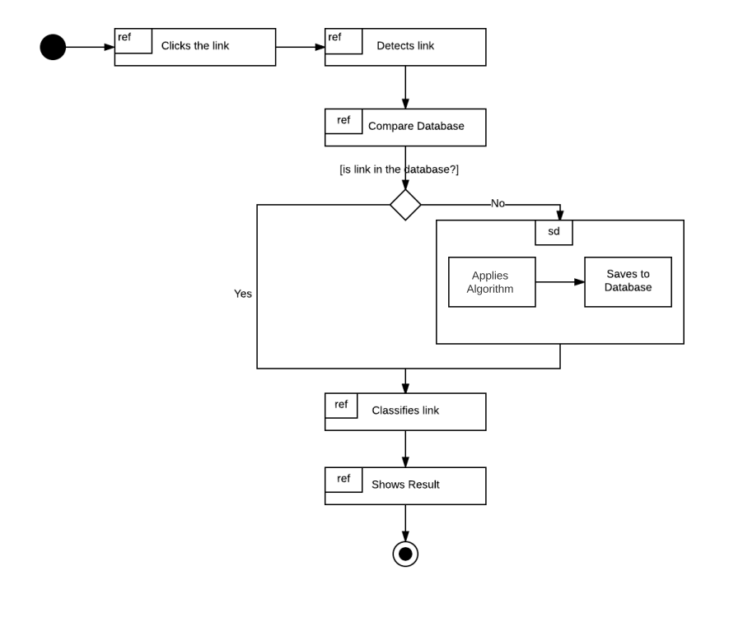

**Object Diagram**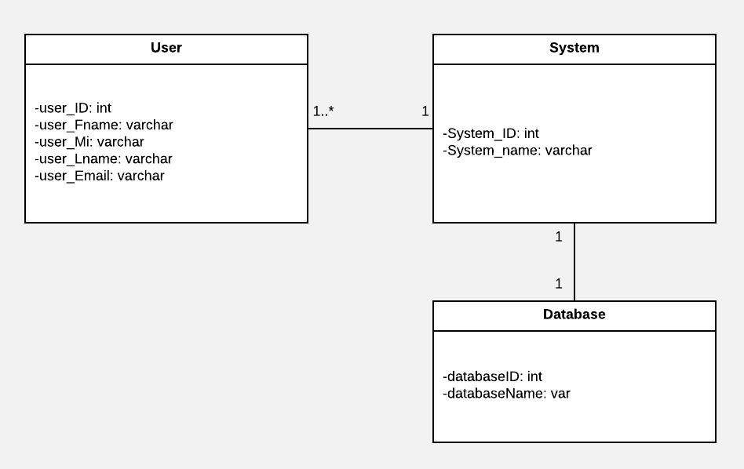

**Package Diagram**

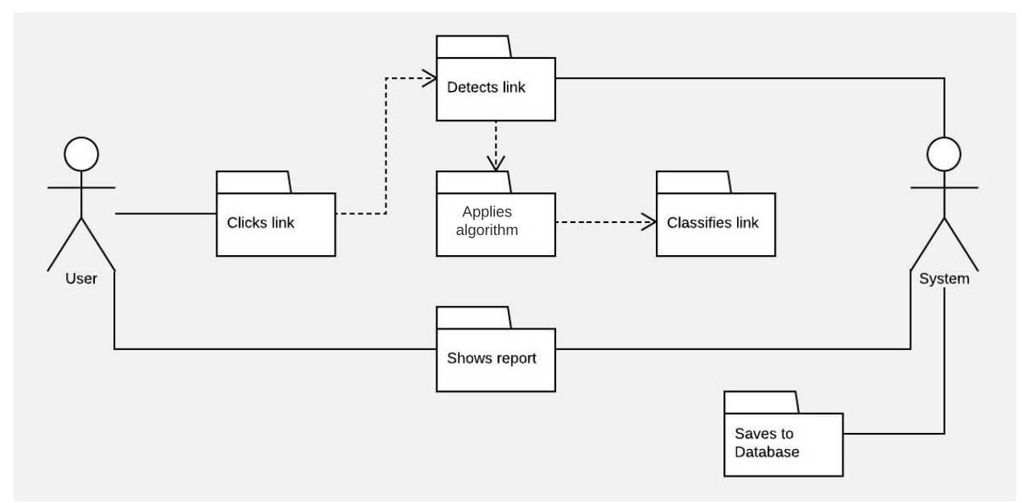

**Deployment Diagram**

